Basic Configurations
To go to root user use the command; sudo -i
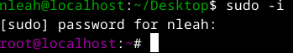
To create a normal user use the command; sudo adduser username then to give it a password use the command; sudo passwd username then to give it priviledges use the command; sudo usermod -aG wheel username to change to the user use the command; su - username
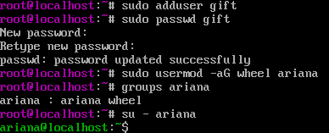
To see all files and directory use the command; ls
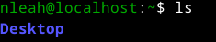
To change from one directory/file use the command; cd file/directory name
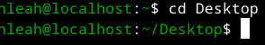
To create a directory use the command; mkdir directory name
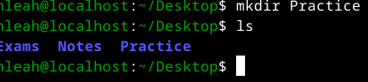
To create a file use the command; touch filename
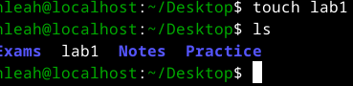

To see the present working directory use the command; pwd
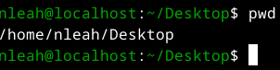
To add contents to a file use the command; nano filename
NOTE; To save and exit from nano use ctrl+X
To view file content use the command; cat filename
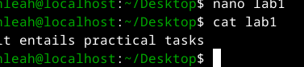
If you don’t have nano use the command ; sudo dnf install nano -y
NOTE; To install packages we use dnf

